Working With Dataset

# Average Age For Different Chest Pain Types

|  |  |
| --- | --- |
| Team ID | PNT2022TMID04535 |
| Project Name | Visualizing and Predicting Heart Diseases with an Interactive Dashboard |

## Visualization:

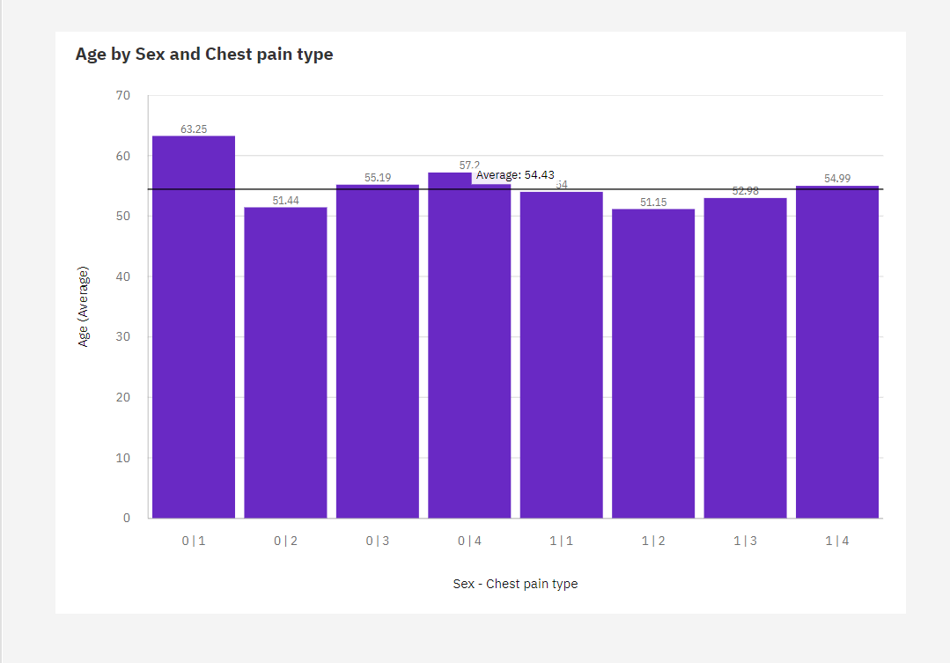

1. Over all **sex - chest pain types**, the average of **Age** is 2.174.
2. The average values of **Age** range from 0, occurring when **Sex - Chest pain type** is 0|1, to 3, when **Sex - Chest pain type** is 0|1.
3. The most common value of Sex - Chest pain type is 0|2, occurring 183 times, which is 67.8 % of the total.